docker commands:

 dockerx build -f Dockerfile -t eureka .

 dockerx run -p 8088:6130 eureka

dockerx images

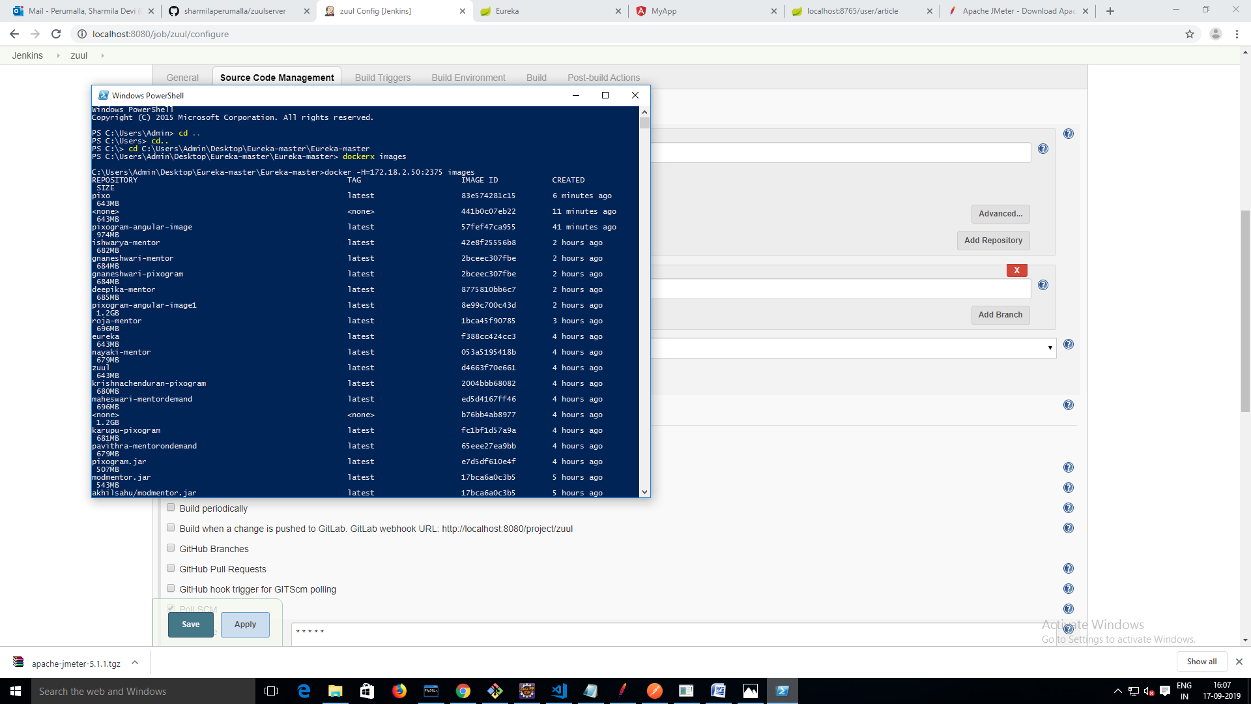

 dockerx build -f Dockerfile -t userent .

 dockerx run -p 8088:6130 userent

dockerx images

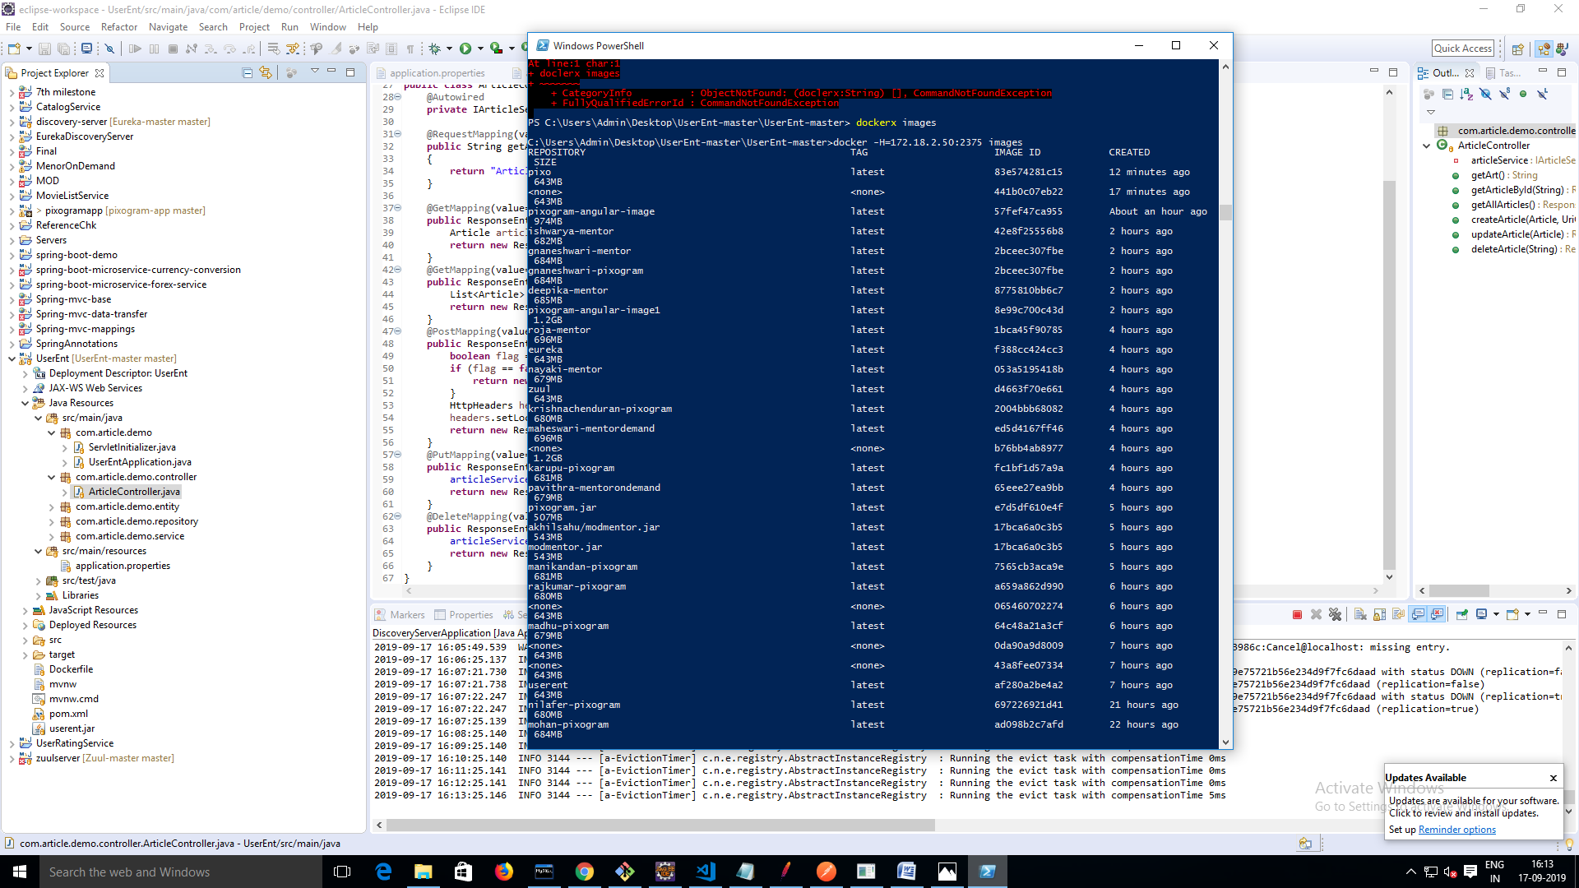

 dockerx build -f Dockerfile -t zuul .

 dockerx run -p 8088:6130 zuul

dockerx images

